P5, Page 366

a)

**Address Range Link**

11100000 00 0

11100001 000000 1

1110000 2

11100001 1 3

Otherwise 3

b)

First address matches 5th entry, link interface 3

Second address matches 3rd entry, link interface 2

Third address matches 4th entry, link interface 3

P6, Page 366

a)

address: 00000000 – 00111111

link 0

address: 01000000 – 01011111

link 1

address: 01100000 – 01111111

link 2

address: 10000000 – 10111111

link 2

address: 11000000 – 11111111

link 3

num address for 0: 64

num address for 1: 32

num address for 2: 96

num address for 3: 64

P7, Page 367

a)

11000000 link interface = 0

32 addresses

11011111

10000000 link interface = 1

64 addresses

10111111

11100000 link interface = 2

32 addresses

11111111

00000000 link interface = 3

128 addresses

01111111

P8, Page 367

223.1.17.0/26

223.1.17.128/25

223.1.17.192/28

P11, Page 367

Any IP address in range 128.119.40.128 to 128.119.40.191

Four equal sized subnets:

128.119.40.64/28,

128.119.40.80/28,

128.119.40.96/28,

128.119.40.112/28

P3, Page 429

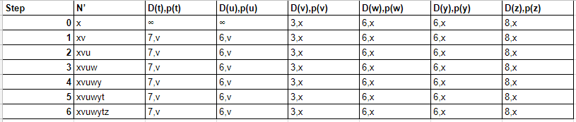

P5, Page 429

